Assignment 01

Study of Ubuntu OS:

Introduction to Linux and Ubuntu:

**Linux:** Linux is a free and open-source operating system kernel that was created by Finnish computer science student Linus Torvalds in 1991. It was initially developed as a personal project to create a Unix-like OS that could run on personal computers equipped with Intel's 80386 processors. The kernel serves as the core of the operating system, managing hardware resources and enabling communication between software and hardware. Linux is distributed under the GNU General Public License (GPL), which allows anyone to view, modify, and distribute its source code.

Over the years, Linux has evolved into a versatile OS that powers a wide range of devices, including desktops, servers, smartphones (e.g., Android), supercomputers, and embedded systems. Its modular and monolithic kernel design supports dynamic loading of components, making it highly adaptable.

**Ubuntu:** Ubuntu is a popular Linux distribution developed by Canonical Ltd., first released in October 2004. It is based on Debian but designed to be more user-friendly and accessible to both beginners and advanced users. The name "Ubuntu" comes from an African philosophy meaning "humanity to others," reflecting its open-source ethos.

Ubuntu is available in various editions tailored for different use cases:

**Desktop**: For personal computers with a graphical user interface.

**Server**: Optimized for server environments.

**Core**: Designed for IOT devices and robotics.

Canonical provides long-term support (LTS) versions every two years, offering five years of free updates for stability-focused users. Regular interim releases are issued every six months with newer features but shorter support cycles

Versions of linux:

Linux is an open-source operating system kernel. Different organizations and communities create Linux distributions (distros) by customizing the Linux kernel with software packages and desktop environments.

1. **Debian**: Known for stability and free software policies. It is the foundation for many other distros like Ubuntu.
2. **Ubuntu**: User-friendly and widely used on desktops and servers, based on Debian.
3. **Fedora**: Sponsored by Red Hat, focuses on the latest technology and innovations.
4. **Arch Linux**: Minimalist and follows a rolling release model. It requires manual setup.
5. **CentOS Stream**: Upstream of Red Hat Enterprise Linux (RHEL), used in enterprise environments.
6. **openSUSE**: Offers two versions – Leap (stable) and Tumbleweed (rolling release).
7. **Kali Linux**: Designed for cybersecurity and penetration testing.
8. **Linux Mint**: Based on Ubuntu, it is beginner-friendly and easy to use.

**Versions of Ubuntu:**

Ubuntu offers different versions (flavors) for specific user needs:

1. **Ubuntu Desktop**: Standard version with the **GNOME** desktop environment.
2. **Ubuntu Server**: Optimized for servers without a graphical interface.
3. **Kubuntu**: Uses the **KDE Plasma** desktop environment.
4. **Xubuntu**: Lightweight version using the **Xfce** desktop.
5. **Lubuntu**: Ultra-lightweight version using the **LXQt** desktop.
6. **Ubuntu MATE**: Classic desktop environment using **MATE**.
7. **Ubuntu Studio**: Designed for multimedia production (audio, video editing).

History:

Linux:

1. **Origins (1991)**
   * **Linux** was created by **Linus Torvalds**, a computer science student from Finland.
   * He developed it as a free, open-source alternative to **MINIX**, a UNIX-like operating system used for educational purposes.
   * Torvalds released the first version of the **Linux kernel** (version 0.01) on **September 17, 1991**.
2. **Open-Source Movement**
   * Linux was released under the **GNU General Public License (GPL)**, allowing anyone to modify and distribute it.
   * The collaboration between **Linux** (kernel) and **GNU software** led to the development of a complete open-source operating system.
3. **Development of Linux Distributions (Mid-1990s)**
   * The first Linux distributions (or "distros") combined the Linux kernel with software packages.
   * **Slackware (1993)** was the first widely-used Linux distribution.
   * **Debian (1993)** and **Red Hat (1994)** followed, providing more user-friendly experiences.
4. **Modern Growth (2000s - Present)**
   * Linux became the foundation for many specialized distributions like **Ubuntu**, **Fedora**, **Arch**, and **CentOS**.
   * It powers a wide range of devices, from **servers** and **supercomputers** to **Android smartphones** and **IoT devices**.

Ubuntu:

1. **Origins (2004)**
   * **Ubuntu** was founded by **Mark Shuttleworth**, a South African entrepreneur and former Debian developer.
   * It was developed by **Canonical Ltd.**, a company Shuttleworth created to support and maintain Ubuntu.
   * The first official Ubuntu release, **Ubuntu 4.10 (Warty Warthog)**, was launched on **October 20, 2004**.
2. **Philosophy**
   * Ubuntu is based on **Debian** and follows the philosophy of **"Linux for human beings,"** focusing on usability and accessibility.
   * It emphasizes **free**, **open-source software** and **community** involvement.
3. **LTS and Regular Releases**
   * Ubuntu introduced a **6-month release cycle** for new features and improvements.
   * **Long-Term Support (LTS)** releases began in 2006, offering **5 years of support** for enterprise and server environments.
4. **Major Milestones**
   * **Ubuntu 6.06 LTS (Dapper Drake)** – First **LTS** version (2006).
   * **Ubuntu 12.04 LTS (Precise Pangolin)** – Widely adopted in enterprise environments (2012).
   * **Ubuntu 20.04 LTS (Focal Fossa)** – Featured improved performance and security (2020).
5. **Ubuntu Today**
   * Ubuntu is available in multiple editions: **Desktop**, **Server**, **Cloud**, and **Core** (for IoT).
   * It powers large-scale systems, including **supercomputers**, **cloud services**, and **AI** platforms.

Features of Ubuntu:

**User-Friendly Interface:** Ubuntu uses the GNOME desktop environment by default, providing a clean and intuitive interface suitable for both beginners and advanced users.

**Free and Open Source:** Ubuntu is free to download, use, and modify, making it an attractive option for users and developers alike.

**Software Center:** Ubuntu comes with a built-in **Software Center** that makes it easy to find and install applications with just a few clicks.

**Security:** Ubuntu is known for its security features, including regular security updates, a firewall, and access controls (AppArmor). The **sudo** command also adds an additional layer of security for system administration tasks.

**Software Updates:** Ubuntu regularly releases software and security updates, ensuring that the system remains up to date with the latest features and patches.

**Support for Multiple Architectures:** Ubuntu supports a wide range of hardware architectures, including x86, ARM, and PowerPC.

**Community Support:** Ubuntu has an active and large community that offers a wealth of tutorials, forums, and online resources to assist users.

**Customization:** Ubuntu is highly customizable, allowing users to tweak almost every aspect of the operating system, from themes to system settings.

**Package Management:** Ubuntu uses the **APT (Advanced Package Tool)** system for installing, updating, and removing software. Packages are downloaded from a central repository, ensuring consistency and security.

Installing Ubuntu:

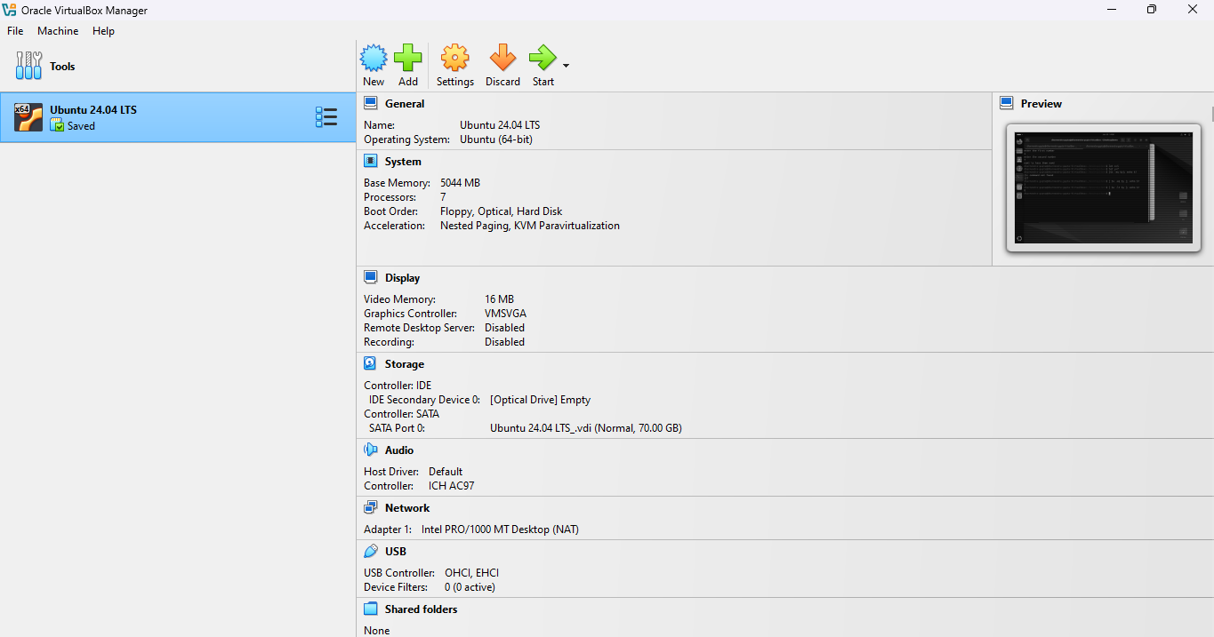

Difference between Ubuntu and Window OS:

| **Feature** | **Ubuntu (Linux)** | **Windows OS** |
| --- | --- | --- |
| **User Interface** | GNOME desktop environment (default) | Windows desktop with Taskbar, Start menu, and File Explorer |
| **Cost** | Free, open-source | Paid, requires a license |
| **Source Code** | Open-source (anyone can modify) | Closed-source (proprietary) |
| **Security** | Built-in firewall, regular security updates | Regular updates, but less secure than Linux by default |
| **Performance** | Generally faster, especially on older hardware | Can be resource-heavy, especially with newer versions |
| **Customization** | Highly customizable | Limited customization options for users |
| **Software Availability** | Software available via APT or Software Center | Wide variety of commercial and third-party software |
| **System Resource Usage** | Lightweight, low system resource usage | Requires more resources, especially with newer versions |
| **Virus/Malware Protection** | Less vulnerable to viruses and malware | More vulnerable to viruses, requires antivirus software |
| **System Administration** | Command-line interface, terminal-based | Graphical User Interface (GUI)-based, easier for beginners |
| **Software Installation** | Uses package managers (APT) for software | Software is installed via .exe or .msi files |
| **Popularity** | Popular among developers and technical users | Dominates the personal desktop market globally |

**Conclusion** Ubuntu is a highly versatile and user-friendly Linux distribution, offering significant advantages over Windows in terms of security, performance, and cost. It is particularly favored for its ease of use, large community support, and customization capabilities. While Windows remains the dominant operating system in the personal computing space, Ubuntu is a compelling choice for users looking to explore Linux or those seeking an alternative OS for security and performance reasons.